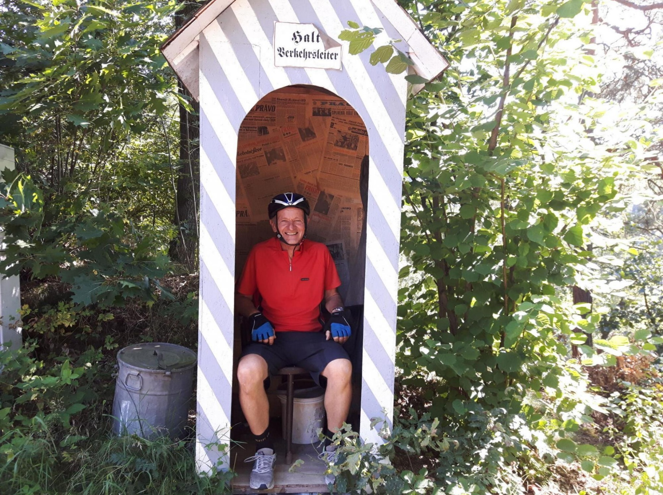**Dr. Petr UCHYTIL**

Institute of Chemical Process Fundamentals of the Czech Academy of Sciences, Prague, Czech Republic

E-mail: [Uchytil@icpf.cas.cz](mailto:Uchytil@icpf.cas.cz)

TEL: +420220390268

**EDUCATION**

‧ 1982, **Ph. D.** inPhysical Chemistry, Institute of Chemical Process Fundamentals of the Czech Academy of Sciences (ICPF), Prague, Czech Republic

‧ 1978, **M.Sc.** inPhysical and Analytical Chemistry, University of Chemistry and Technology Prague (UCT), Prague, Czech Republic

**WORK EXPERIENCE**

* 2018~present, Senior researcher, Department of Organic Compounds and Nanocomposites, Institute of Chemical Process Fundamentals of the CAS
* 2015~2018, Senior researcher, E. Hala Laboratory, Institute of Chemical Process Fundamentals of the CAS
* 1986~2015, Senior researcher, Department of Separation Processes, Institute of Chemical Process Fundamentals of the CAS
* 1984~1985, Researcher, Institute of Chemical Process Fundamentals of the CAS
* 1982~1983, Postdoctoral Fellow, Institute of Chemical Process Fundamentals of the CAS

**INTERNATIONAL EXPERIENCES**

* 1992, Laboratory of Physical Chemistry of Macromolecules, France, laboratory of Prof. Néel and Dr. Nguyen
* 1996,1998, University of Hiroshima, Laboratory of Prof. M. Asaeda
* 1994~2015, Every year he is visiting the laboratory of Prof. A. Seidel-Morgenstern at the University of Magdeburg Max-Planck Institute, collaboration in the field of adsorption and surface diffusion.
* 2000~present, Collaboration with Dr. S. Kononovou (Institute of Macromolecular Compounds, Russian Academy of Sciences, Saint-Petersburg, Russia) in the field of separation of organic compounds by pervaporation.
* 2006~present, Collaboration with Dr. Thomas Loimer (Technische Universität Wien) in the field of vapor transport through ceramic membranes.
* 2007~2011, Collaboration with Prof. R.D. Noble (Department of Chemical and Biological Engineering, University of Colorado, Boulder, USA), common project focused on the use of ionic liquids to gas separation.
* 2009~present, Collaboration with National Chung Hsing University, Taichung, Taiwan. Prof. S.Y. Suen, Prof. H.H. Tseng, Bilateral projects – preparation and testing of new membranes for CO2/CH4 separation,

**PRESENT RESEARCH INTERESTS**

Membrane separation processes, transport in polymeric, inorganic and liquid membranes, pervaporation and gas/vapor separation, ionic liquids, dendrimers, new composite material.

**AWARDS AND HONORS**

Outstanding Master Thesis 1978 (UCT)

Academy of Sciences of the Czech Republic (1984)