Functionalized semiconductor nanostructures for future electronic and energy related devices
Naoki Fukata
International Center for Materials Nanoarchitectonics (MANA),
National Institute for Materials Science (NIMS)
E-mail: FUKATA.Naoki@nims.go.jp
Brief Biography of Speaker: Naoki Fukata is a Group Leader of Nanostructured Semiconducting Materials Group and a Principal Investigator (PI) of International Center for Materials Nanoarchitectonics (MANA) in National Institute for Materials Science (NIMS). He received his Ph.D. in engineering from University of Tsukuba. He worked at Tohoku University as an Associate Professor and then a Lecturer at University of Tsukuba. He is working at NIMS since 2005. His research group is focused on the functionalization of semiconducting nanomaterials for the applications of next-generation high speed transistors and high efﬁciency solar cells.
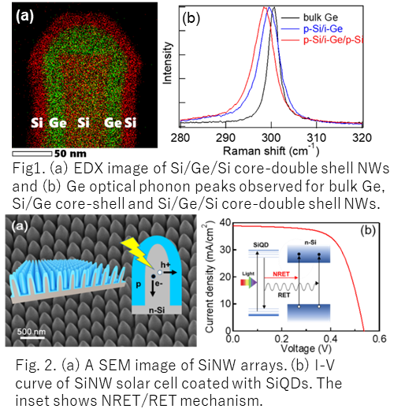
Abstract: Semiconductor nanostructures such as nanowires (NWs) and nanocrystals (NCs) are anticipated for the realization of next-generation high-speed field-effect transistors, high efficiency solar cells, high-capacity Li ion batteries and so on. In this meeting, the first two applications using NWs and NCs are introduced. Core-shell NWs composed of Si and Ge can realize high mobility transistor channels, since the carrier transport region can be separated from the impurity doped region, resulting in the suppression of impurity scattering. The direct evidence of hole gas accumulation in impurity undoped regions in core-shell NWs was obtained by the Fano effect appeared in optical phonon modes (Fig. 1). SiNW solar cells using the core-shell fabrication process improve the energy conversion efficiency by constructing radial pn junctions in SiNWs. This structure also has an advantage of significantly low light reflection. A new solar cell paradigm has also recently been proposed using non-radiative energy transfer (NRET) between semiconductor QDs and SiNW solar cells (Fig. 2). The maximum energy conversion efficiency of 14.3 % has been obtained so far.
[1] X. Zhang et al., ACS Nano 13, 13403 (2019). [2] N. Fukata et al., ACS Nano 9, 12182 (2015). [3] N. Fukata et al., Small 13, 1701713 (2017). [4] M. Dutta, et al., ACS Nano 9, 6891 (2015). [5] M. F. Abdelbar et al., Nano Energy 77, 105163 (2020). [6] Mostafa F. Abdelbar et al., Nano Energy 89, 106470 (2021).

